Academic Year: 2024-25 | Year: First Year | Term: I
Roll No.: | 11
Name: | Riddhee Sandeep Kulkarni
Subject: FCP
Assignment No.: | 29
Title: | File read and write
Date:

Contents
1. Theory (Logic) 2
2. Pseudo Code 2
3. Program Code 2
4. Output 2
5. Conclusion 2

THEORY:

This code reverses the content of a file and writes it to another file, demonstrating the use

of fseek for random access file manipulation.

PSEUDO CODE:

Step 1: Start

Step 2: define variables

Step 3: define main function

Step 4: accept file names from user

Step 5: write code to read from a file and write the content to another file in reverse order

Step 5: print output

Step 6: end

PROGRAM CODE:

#include <stdio.h>

#include <stdlib.h>

int main()

{

FILE *sourceFile, *destFile;

char sourceName[100], destName[100];

char ch;

long fileSize, i;

printf("Enter the source file name: ");

scanf("%s", sourceName);

printf("Enter the destination file name: ");

scanf("%s", destName);

sourceFile = fopen(sourceName, "r");

if (sourceFile == NULL)

{

printf("Error: Cannot open source file.\n");

exit(1);

}

destFile = fopen(destName, "w");

if (destFile == NULL)

{

printf("Error: Cannot create destination

file.\n"); fclose(sourceFile); exit(1);

}

fseek(sourceFile, 0, SEEK_END);

fileSize = ftell(sourceFile);

for (i = fileSize - 1; i >= 0; i--)

{

fseek(sourceFile, i, SEEK_SET);

ch = fgetc(sourceFile);

fputc(ch, destFile);

}

printf("Content reversed and written to the destination file successfully.\n");

fclose(sourceFile);

fclose(destFile);

return 0;

}

OUTPUT:

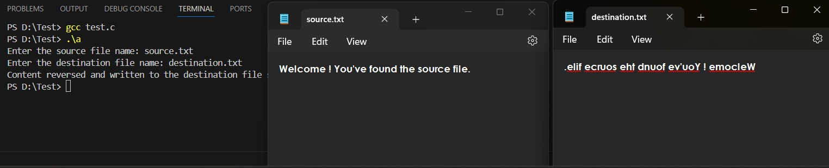

CONCULSION:

Code is run successfully, required output received

